Research Planning from machine learning for prostate segmentation
Part 1: Make synthetic images from the real images
Subpart 1: Train a VAE-GAN with spade layers:
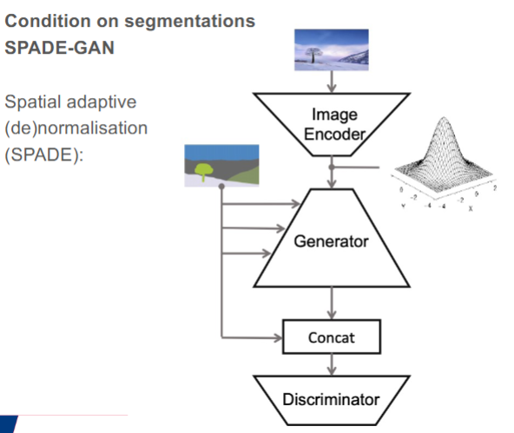
To Do’s:
- Finish the VAE and connect it to the discriminator using the code Cian Schannel set up online.
  - Finish the following files
    - Vae.py
    - Train_vae.py
  - Check if training works properly and new images seem similar
- Add the discriminator after the Vae and change training to incorporate the right loss parts
- Add SPADE layers in the generator
  - This allows for a specific mask to be used during image segmentation with the goal of having the mask correspond to the generates image.
- Train the model optimally
  - Augment the input images
- Generate good synthetic images
  - Either change the masks or sampling from the latent space
PART 2: U-net
- Train network on only real images
- Train network on combination of real and synthetic images made in step 1
- Validate both trained networks on validation data (20 additional images)

